2026 World Cup most popular markets by number of bets - pre-match and live [2022 ranking]
Pre-match | Live
- Full time [1]  - Player shots on target [4]  - Total goals [2]  - Correct score [3]  - Player to score [5]  - Both teams to score [6]  - Player shots [12]  - To score or assist [n/a]  - To score at least X goals [13]  - To assist [18] | - Full time [1]  - Player shots on target [n/a]  - Total goals [2]  - Correct score [3]  - Player to score [6]  - Total goals – 1st half [7]  - Team to go through [9]  - Player shots on target – first two minutes of match [n/a]  - Total goals – first two minutes of match [5]  - Half time [8]

Increase in number of bets 2022 World Cup to 2026 World Cup – 53%

2026 World Cup most popular players by number of bets
- Kylian Mbappe
- Lonel Messi
- Harry Kane
- Lamine Yamal
- Erling Haaland
2026 World Cup most popular matches by number of bets
- Spain vs. Argentina
- Netherlands vs. Morocco
- Netherlands vs. Japan
- France vs. Morocco
- France vs. Spain

Top pre-match and live player props by % of number of bets
Pre-match | Live
- Player shots on Target – 42%  - To score – 16%  - Player shots – 10%  - To score or assist – 9%  - To score at least X goals – 6% | - Player shots on target – 38%  - To score – 15%  - Player shots on target (first two minutes of match) – 12%  - Player shots – 8%  - Scorer of goal – full time – 7%

Bet builder vs. non bet builder World Cup 2022 compared to World Cup 2026
2022 | 2026
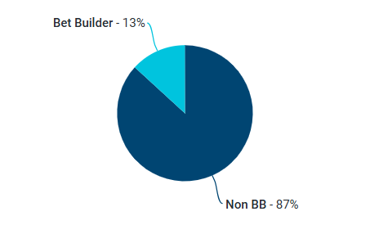 | 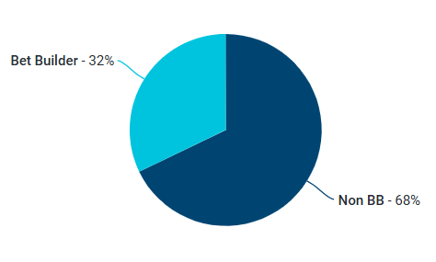

Top Bet Builder selections by number of bets
- Player shots on target
- Player to score
- Full time
- Player shots
- To score or assist

Top teams by number of bets
- France
- Argentina
- Spain
- Netherlands
- England

Top Dutch players by number of bets
- Cody Gakpo
- Brian Brobbey
- Donyell Malen
- Virgil van Dijk
- Denzel Dumfries

PM vs. Live
Pre-match – 78%
Live – 22%

Bet Builder average number of selections
Selection size
2 | 31%
3 | 26%
4 | 23%
5 | 9%
6+ | 11%

Top Netherlands matches by number of bets [overall]
- Netherlands vs. Morocco [2]
- Netherland vs. Japan [3]
- Netherlands vs. Sweden [6]
- Tunisia vs. Netherlands [10]

